2018 Battle Florida

On June 16th the 2nd annual Battle Florida Flag Football Championships were held at the Miami Dolphins Training Facility in Davie, FL.

The tournament was yet another fabulous event, featuring 32 teams from across the state of Florida.

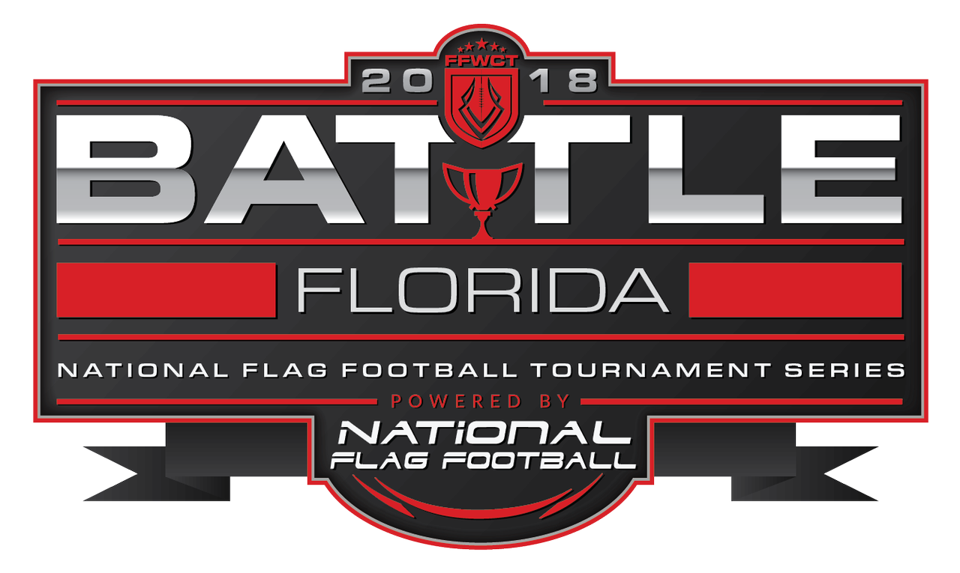Thank you to all of the players, coaches, and sponsors that contributed to making this event so successful!

# *Open 6U Division*

Congratulations to the “MIA Flag” for winning the 6U Division!

The Destroyers were led by Head Coach Mario Fernandez. There were 4 teams competing in this division.

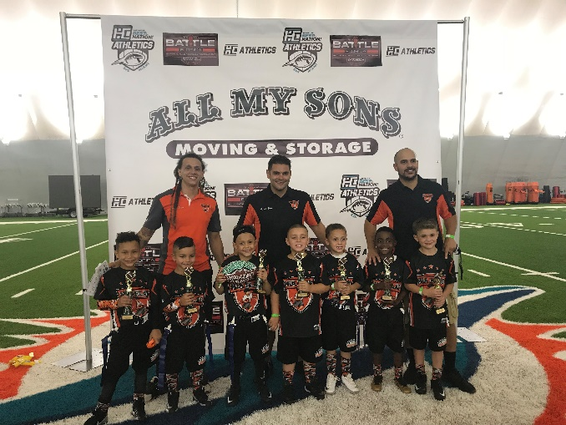 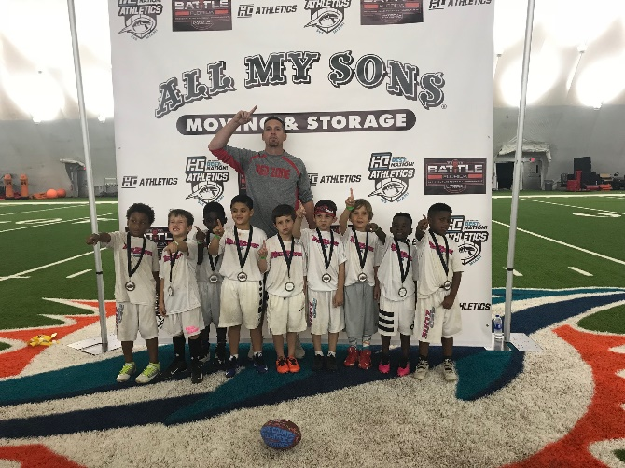

## 1st – MIA Flag (Division Champions)

### 2nd – RedZone (Runner Up)

3rd – Palm City Beast Mode Bills

4th - Ely-M

# 

# *Open 7U Division*

Congratulations to the “Miami Ravens” for winning the 7U Division!

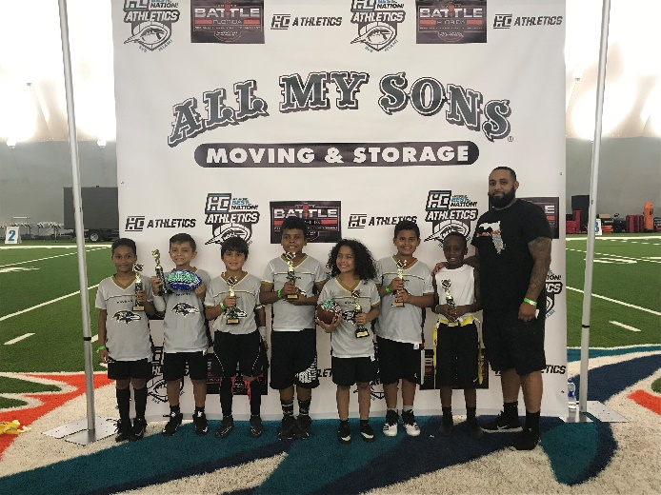The Miami Ravens were led by Head Coach Emanuel Morales. There were 2 teams competing in this division.

## 1st – Miami Ravens (Division Champions)

### 2nd – Annihilators (Runner Up)

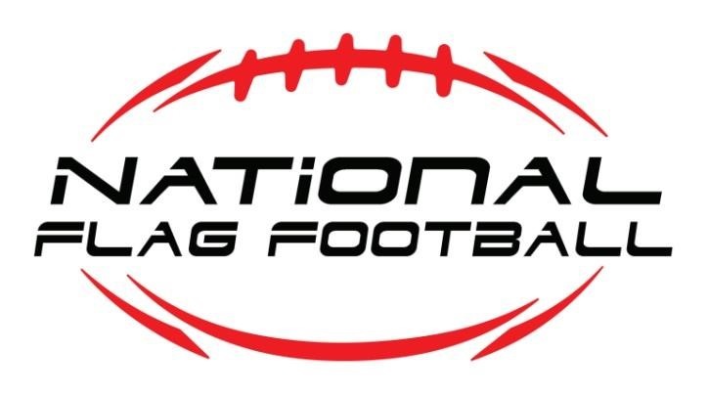

# *Open 8U Division*

Congratulations to “MIA Flag” for winning the 8U Division!

MIA Flag was led by Head Coach Mario Fernandez. There were 4 teams competing in this division.

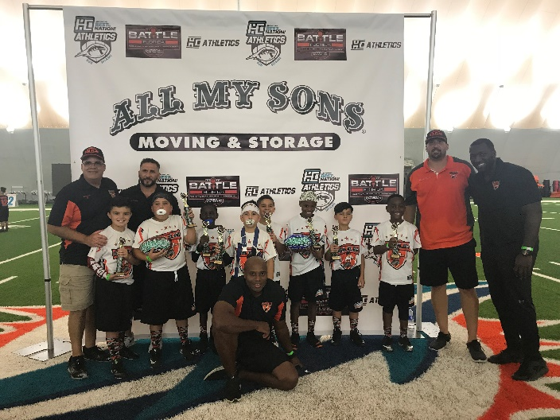

**MIA FLAG**

## 1st – MIA FLAG (Division Champions)

### 2nd – South Florida Storm (Runner Up)

3rd – Boca Dolphins

4th – Blitz War Pigs



# *Open 9U Division*

Congratulations to the “West Boynton Saints” for winning the Open 9U Division!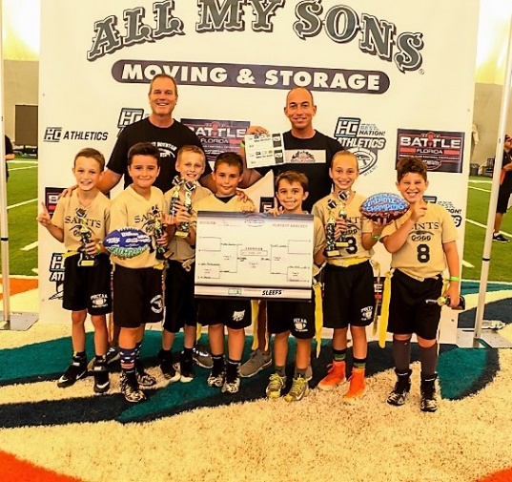 The Saints were led by Head Coach Chris Schroeder. There were 6 teams competing in this division.

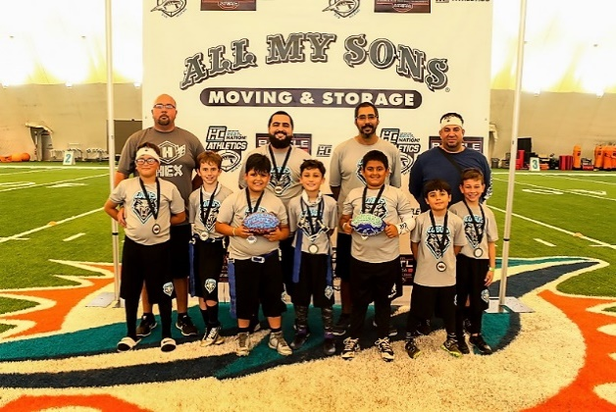

## Saints Lobos

## 1st – West Boynton Saints (Division Champions)

### 2nd – 305 Lobos (Runner Up)

3rd – No Chill

4th – D2D Performance

5th – U Squad

6th – Generals



# Open 10U Division

Congratulations to “RedZone” for winning the 10U Division!

RedZone was led by Head Coach Luis Rodriguez. There were 4 teams in this division.

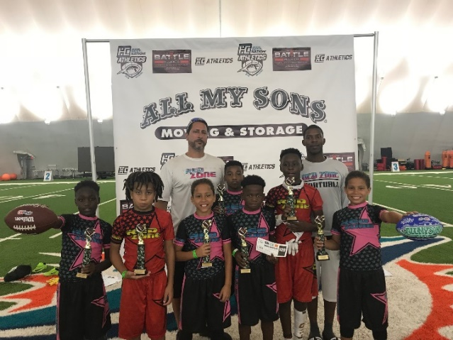 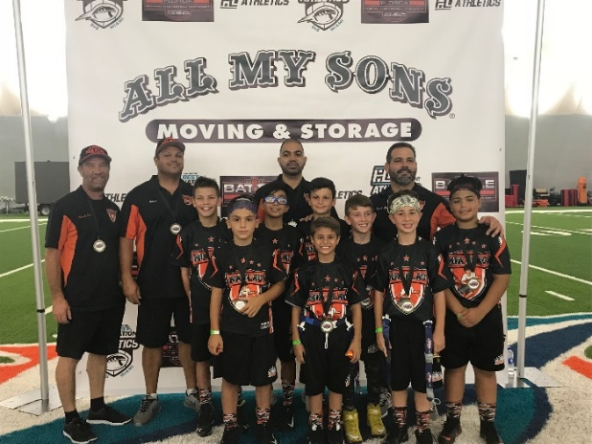

**Redzone**  **MIA Flag**

1st – Redzone (Division Champions)

## 2nd – MIA Flag (Runner Up)

3rd – PSN All Stars

4th – MAR-JCC



# Open 11U Division

Congratulations to “RedZone” for winning the 11U Division!

RedZone was led by Head Coach Luis Rodriguez. There were 3 teams competing in this division.

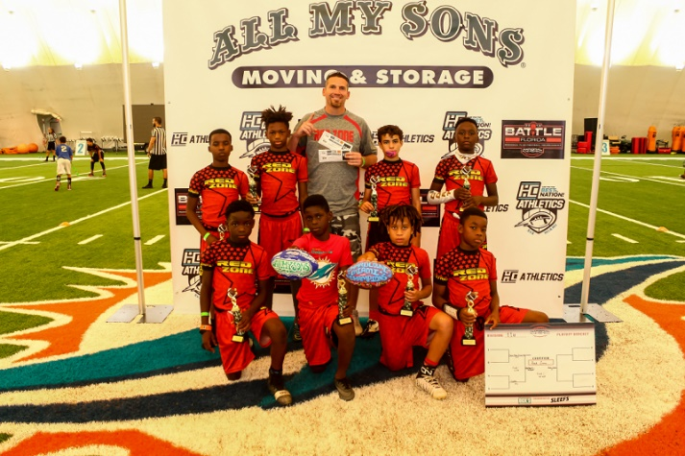 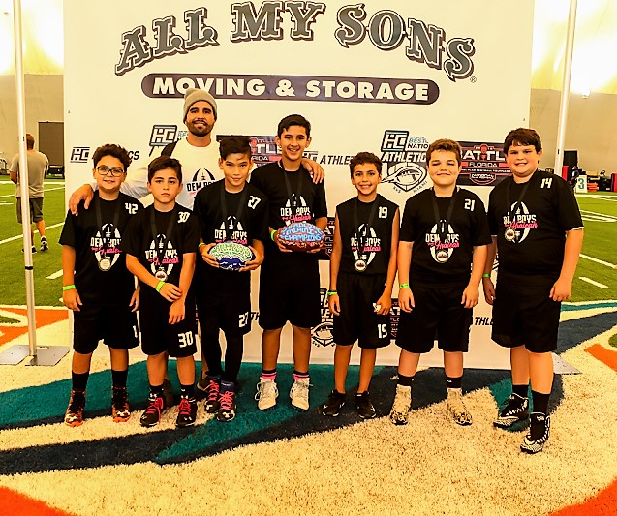

1st – RedZone

2nd – Dem Boys from Hialeah

3rd – Colts



# Open 12U Division

Congratulations to the “MIA Flag” for winning the 12U Division!

The MIA Flag were led by Head Coach Mario Fernandez. There were 4 teams competing in this division.

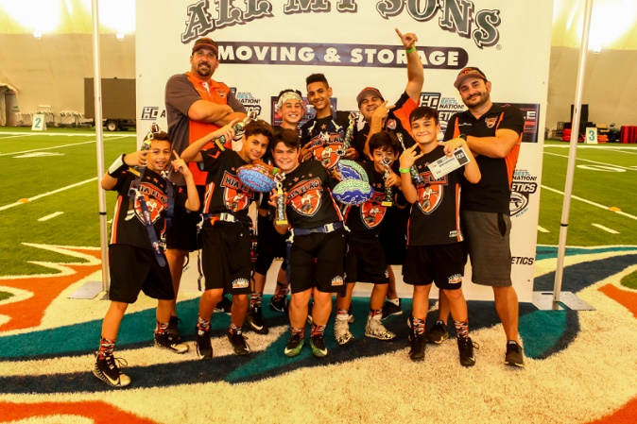 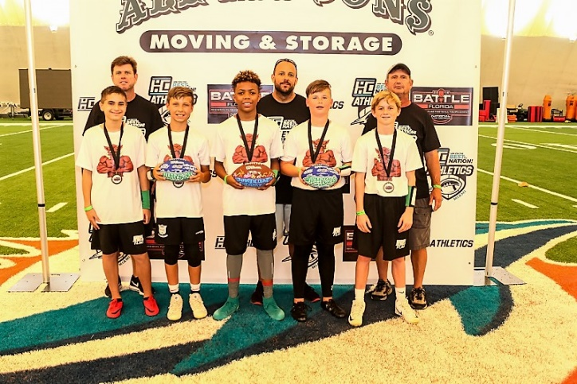

MIA Flag Wellington

1st – MIA Flag (Division Champions)

## 2nd – Wellington 12U (Runner Up)

T -3rd – Men In Black

T-3rd – Annihilators



# Open 15U Division

Congratulations to “RedZone” for winning the 15U Division!

Redzone was led by Head Coach Luis Rodriguez.

There were 4 teams competing in this division.

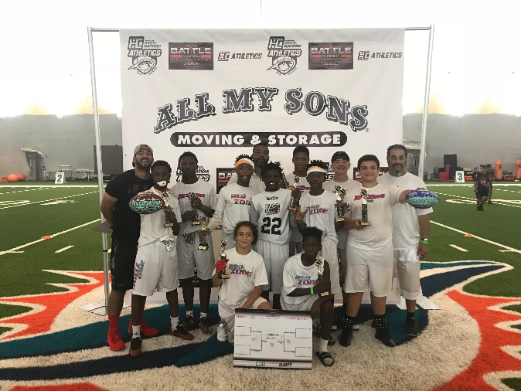 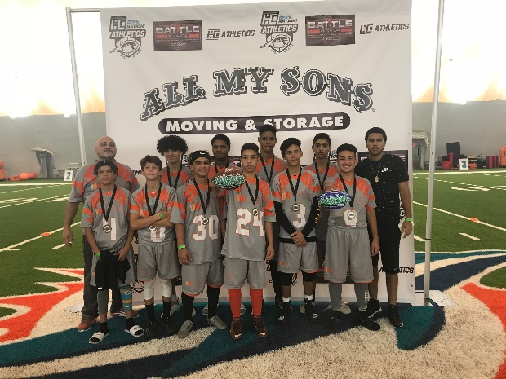

RedZone

1st – RedZone (Division Champions)

**2nd – Fade Tigers (Runner Up)**

3rd – Sean Anderson

4th – Kansas City Chiefs



# NFF 6th Grade & Under Division

Congratulations to the “Chargers” for winning the NFF 6th Grade & Under Division!

The Chargers were led by Head Coach Chris Chicoski.

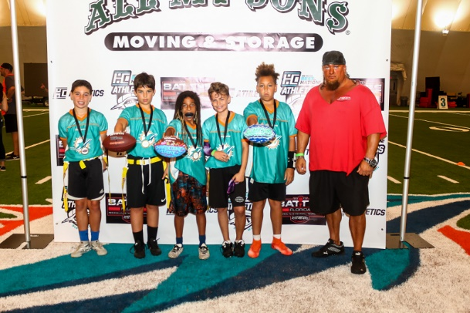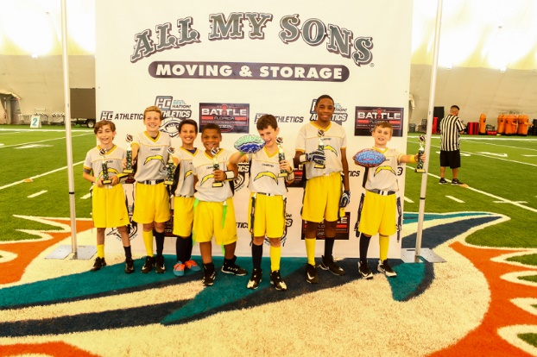There were 2 teams competing in this division

|  |  |  |
| --- | --- | --- |
| Chargers | Dolphins |  |
| 1st – Coconut Creek Chargers (Division Champions)  **2nd – West Palm Beach Dolphins (Runner Up)** |  |  |

